What is Stack Overflow?
A stack overflow happens when the call stack memory gets completely filled, and there is no space left to add new method calls.
In simple words:
Too many method calls are placed on the stack without being removed.

First, What is Stack Memory? (Quick Reminder)
- Stack memory is used to store:
  - Method calls
  - Local variables
  - Parameters
  - Return addresses
- Every time a method is called:
  - A new stack frame is created
- When the method finishes:
  - That stack frame is removed
👉 Stack works in LIFO order (Last In, First Out).

How Stack Overflow Happens
Stack overflow usually happens when:
- A method keeps calling another method
- Or a method keeps calling itself
- And no method ever finishes
Because of this:
- Stack frames keep getting added
- Stack memory fills up
- JVM cannot add more frames
- JVM throws StackOverflowError

Most Common Cause: Infinite Recursion
Example:
void show() {
show(); // method keeps calling itself
}
What happens:
- show() is called → stack frame created
- show() calls show() again → new frame created
- This repeats endlessly
- Stack memory fills up
- JVM throws StackOverflowError
👉 No return → no stack cleanup → overflow

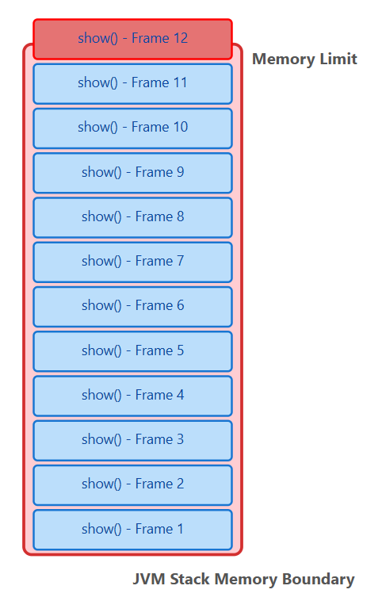

Other Causes of Stack Overflow
- Very deep recursion (even with a base condition)
- Too many nested method calls
- Circular constructor calls using this() or super()
Example:
class A {
A() {
this(); // infinite constructor call
}
}

Important Point to Remember
- Stack overflow is an error, not an exception
- It cannot be handled using try-catch
- It indicates a programming mistake

How to Avoid Stack Overflow
- Always use a base condition in recursion
- Avoid unnecessary deep recursion
- Be careful with constructor chaining
- Prefer loops when recursion is not required

Simple Real-Life Analogy
Think of stack as a plate stack:
- You keep adding plates
- You never remove any
- Stack becomes too tall
- Plates fall
👉 That fall is stack overflow

Note:
Inside a method, you cannot define a new method.
However, you can call another method from inside a method.

Inside a constructor, you cannot call another constructor like a normal method, even if it belongs to the same class.
To call a constructor:
- Use this() to call another constructor of the same class
- Use super() to call a constructor of the parent class
Calling a constructor using the class name is not allowed in Java.

1️⃣ this keyword
👉 What is this?
this is a reference variable that refers to the current object.

👉 Why do we use this?
- To differentiate instance variables from local variables
- To refer to current class object
- To call current class methods
- To pass current object as argument
- To return current object

🔹 Example 1: Differentiating variables
class Student {
int id;

Student(int id) {
this.id = id; // instance variable = local variable
}
}
📌 Without this, Java will use the local variable only.

🔹 Example 2: Calling current class method
class Test {
void show() {
System.out.println("Show method");
}

void display() {
this.show(); // calls current object's method
}
}

🔹 Example 3: Passing current object
class Demo {
void test(Demo d) {
System.out.println("Method called");
}

void call() {
test(this); // passing current object
}
}

🔹 Example 4: Returning current object
class A {
A get() {
return this;
}
}

✅ Key points of this
✔ Refers to current object
✔ Used inside instance methods / constructors
❌ Cannot be used in static context
✔ Helps avoid variable shadowing

2️⃣ this() constructor call
👉 What is this()?
this() is used to call another constructor of the same class.

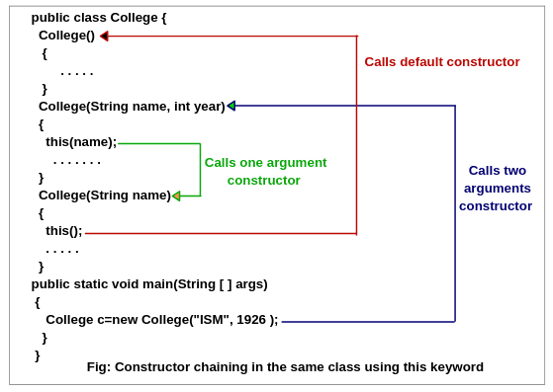
This is called constructor chaining.

🔹 Example
class Employee {
int id;
String name;

Employee() {
this(101, "Pavan"); // calls parameterized constructor
}

Employee(int id, String name) {
this.id = id;
this.name = name;
}
}
📌 When default constructor runs → parameterized constructor runs first.

🔹 Constructor chaining flow
Employee() → this(101,"Pavan") → Employee(int,String)

🚨 Important Rules of this()
- this() must be the first statement in constructor
- Can be used only inside a constructor
- Used to avoid duplicate initialization code
- Cannot call two constructors in the same constructor
- this() and super() cannot be used together
❌ Wrong:
Employee() {
System.out.println("Hello");
this(101); // ❌ compile-time error
}

3️⃣ this vs this() (🔥 MOST IMPORTANT)
Feature | this | this()
Type | Reference variable | Constructor call
Purpose | Refers to current object | Calls another constructor
Used in | Methods & constructors | Constructors only
Position rule | Anywhere | Must be first line
Calls | Current object members | Another constructor
Static allowed | ❌ No | ❌ No

4️⃣ Interview one-liner answers
🟢 What is this?
👉 Reference to the current object.
🟢 What is this()?
👉 Used to call another constructor of the same class.
🟢 Can we use this in static method?
👉 No, because static methods don’t have objects.
🟢 Why this() must be first statement?
👉 To ensure proper constructor chaining and object initialization.

❌ this() is NOT a method
❌ super() is NOT a method
✅ this() → constructor call (constructor invocation)
✅ super() → constructor call (parent constructor invocation)
So you should say:
✔ this constructor / this() constructor call
✔ super constructor / super() constructor call

Why NOT “method”?
1️⃣ Methods have names, return types, and can be called many times
Example:
void show() { }
show(); // method call
But constructors:
- Have same name as class
- Have no return type
- Are called only during object creation

2️⃣ this() and super() behave like constructors
Even though they look like method calls, they are special constructor calls handled by the JVM.
class A {
A() {
System.out.println("A constructor");
}
}

class B extends A {
B() {
super(); // calls A's constructor
System.out.println("B constructor");
}
}
📌 Here:
- super() → calls parent constructor
- this() → calls another constructor of same class
They do NOT call methods.

Correct terminology (🔥 use this in exams & interviews)
Expression | Correct name | Wrong name
this() | this constructor / constructor call | this method ❌
super() | super constructor / parent constructor | super method ❌
this | reference variable | method ❌
super | reference variable | method ❌

